Functions past paper questions



2018

2019

2022 – session 1

- session 2

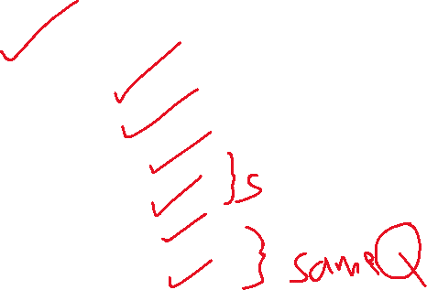

2023 – session1 – VA



- VB

- session2 – VA

- VB

Extra model paper question



2018

2019

2022- session 1

2022- session 2

2023- session 1- VA

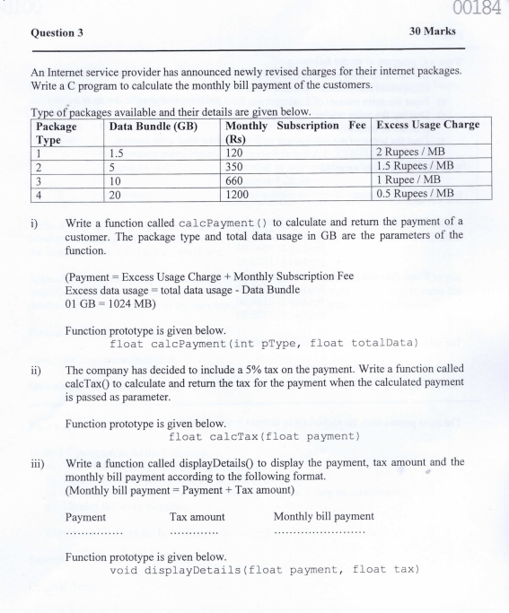



2023- session1 -VB

2023- session 2- VA



2023- session2- VB

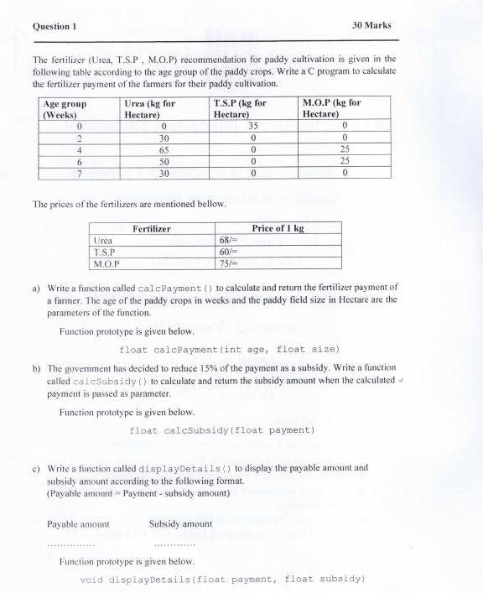

Extra model paper

